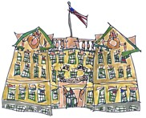 | Lincoln School Parents’ Association  October 16, 2014  Agenda
Upcoming Events  Oct 22-24: Parent/Teacher Conferences; Early Release days.  Nov 4: NO SCHOOL --Professional Day.  Nov 11: NO SCHOOL –  Veteran’s Day  Nov. 13: LSPA Meeting, 8:30am  Nov. 14: Picture Retake Day | - Consent agenda:  Minutes from September 2014 meeting  Treasurer’s Report through September 2014  - Principal's Report  - Co-Presidents’ Report  - Committee Reports  - New Initiatives Discussion  Next LSPA Meeting  Thursday, November 13th  8:30 am

